Cub Scout Sports
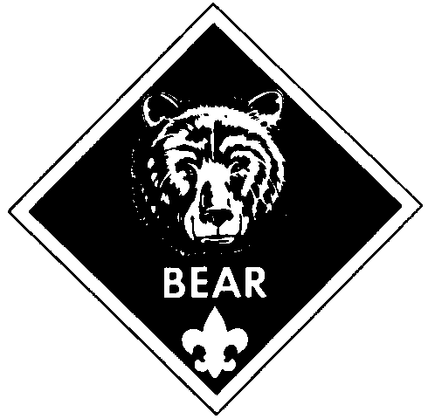
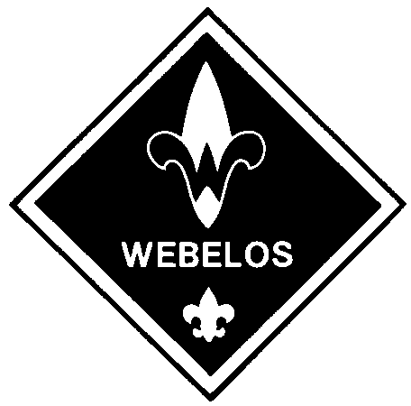

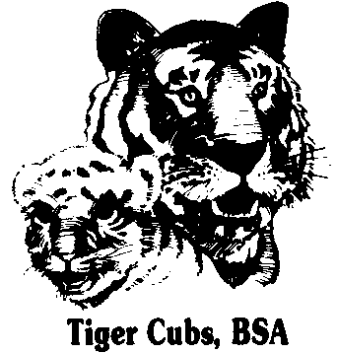
Den Recognition Report

When requesting Cub Scout Sports recognition items, den leaders should enter B for belt loops and P for pins. Present the den’s recognition report at the next pack leaders’ meeting so that a composite pack request can be compiled. Awards should be available for presentation at the next pack meeting.

Den No. _____________ Pack No. _______  Date _________________  Names | Sports Belt Loops and Pins
 | Badminton | Baseball | Basketball | Bicycling | Bowling | Fishing | Flag Football | Golf | Gymnastics | Ice Skating | Marbles | Physical Fitness | Roller Skating | Snow Ski and Board Sports | Soccer | Softball | Swimming | Table Tennis | Tennis | Ultimate | Volleyball

Den Leader __________________________________________ _____________
Signature Date

